**What’s happening at Checkendon Pre-school:**

**Look what we have been doing….**

WE have been fathers day sunflowers growing crtive cards more inddor outdoor free flow play. Gardening the flower beds adding flowers and growing our pumpkin,. Thankyou to lorna who has very kindly fille dour beds with soil to plant our pumpkins.

We are looking forward to our sports day and leavers celebrations

To find out more about Checkendon Pre-School, do visit our website [www.checkendonpreschool.co.uk](http://www.checkendonpreschool.co.uk), call us on 01491 682589, e-mail preschoolcheckendon@gmail.com or just pop in – we always look forward to welcoming you to Checkendon Pre-School.

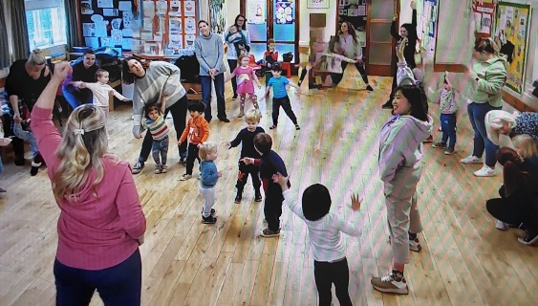 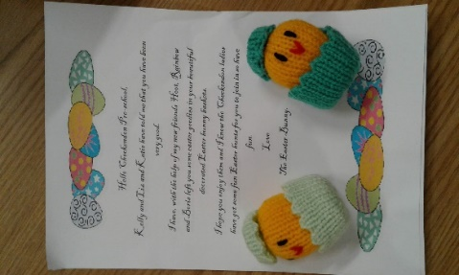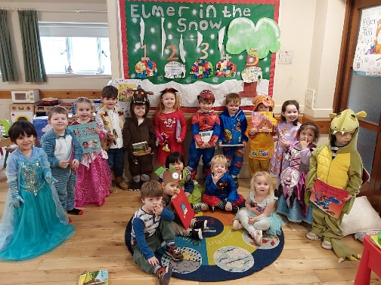

**Easter Bunny**

**Mother’s Day Diddi Dance**

**1**

**1**

**World Book Day**

All Enquiries please contact: [preschoolcheckendon@gmail.com](mailto:preschoolcheckendon@gmail.com), Tel: 01491 682589 [www.checkendonpreschool.co.uk](http://www.checkendonpreschool.co.uk)

**Ways you can support Checkendon Pre-School**

**Easy fundraising. Please support the Pre-School and sign up to raise funds for the Pre-School -** [**https://www.easyfundraising.org.uk/causes/checkendonpreschool/**](https://www.easyfundraising.org.uk/causes/checkendonpreschool/)