**What’s happening at Checkendon Pre-school:**

**Look what we have been doing….**

We have been making the most of the lovely weather enjoying lots of time outdoors, exploring the world around us. We have been planting lots of exciting things for our flower beds, such as Pumpkins, Sunflowers and Dahlias. Learning about how things grow and what they need. We have also been planting our very own sunflowers for our dads for Father’s Day. We have been weeding and preparing our flower beds ready to plant the things that we have grown. Thank you to Richard for building our new flower box and Lorna from Checkendon Court, who has very kindly filled it with soil so we can plant our flowers, pumpkins and sunflowers.

We have lots to look forward to in the coming term with the children’s favourite activity….. Sports Day followed by a family picnic on the field, Leavers Celebrations and end of term party.

Through fundraising we have raised over £500 are pleased to say we have been able to buy some wonderful new resources to support the childrens play. Thank you for your continued support.

To find out more about Checkendon Pre-School, do visit our website [www.checkendonpreschool.co.uk](http://www.checkendonpreschool.co.uk), call us on 01491 682589, e-mail preschoolcheckendon@gmail.com or just pop in – we always look forward to welcoming you to Checkendon Pre-School.

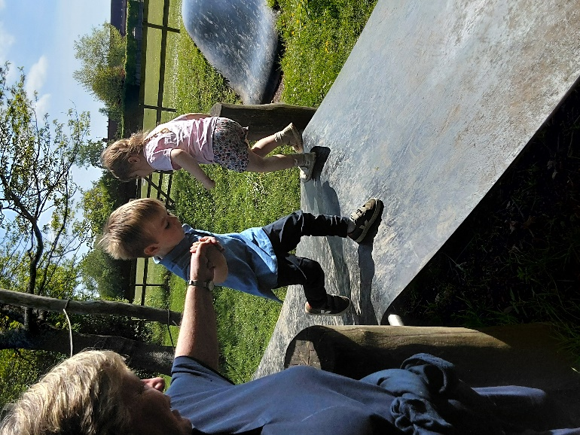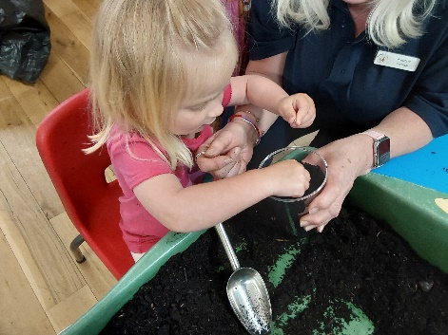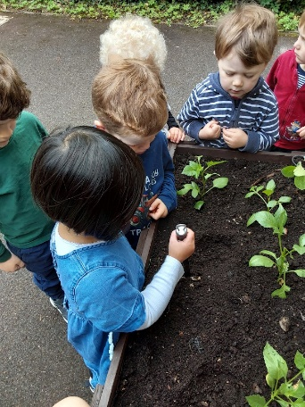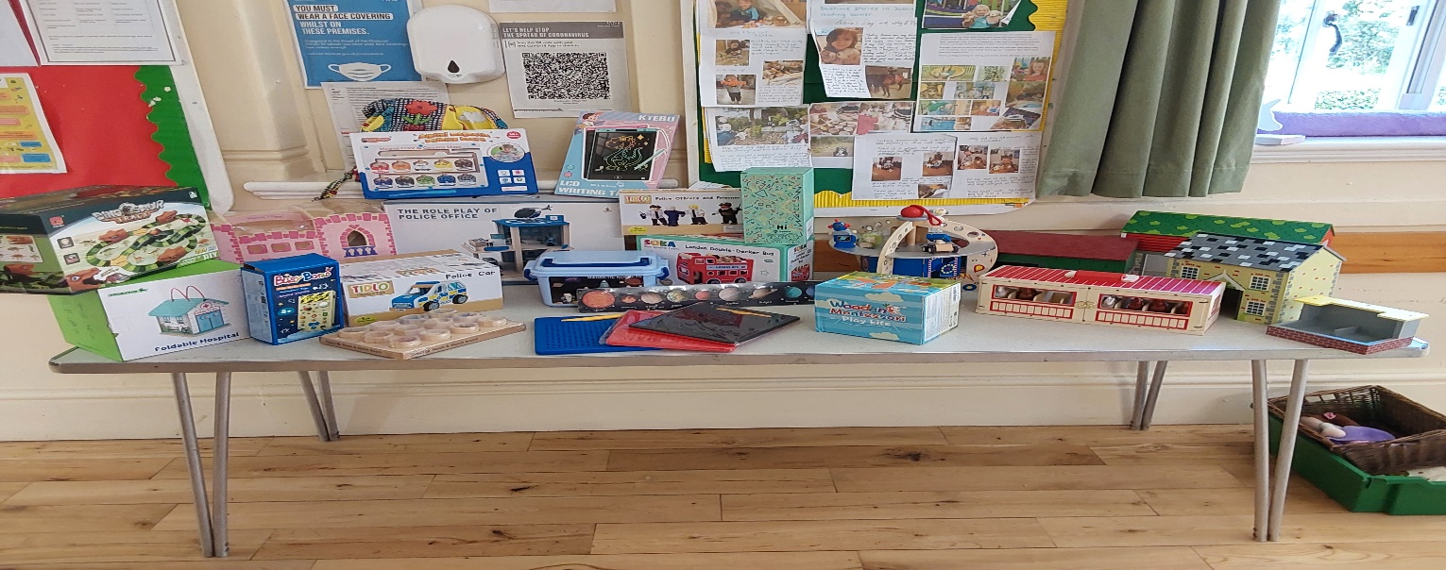

**Planting**

**Outdoor Fun**

**Fathers Day**

**1**

**1**

All Enquiries please contact: [preschoolcheckendon@gmail.com](mailto:preschoolcheckendon@gmail.com), Tel: 01491 682589 [www.checkendonpreschool.co.uk](http://www.checkendonpreschool.co.uk)

**Ways you can support Checkendon Pre-School**

**Easy fundraising. Please support the Pre-School and sign up to raise funds for the Pre-School -**[**https://www.easyfundraising.org.uk/causes/checkendonpreschool/**. We will be helping to prepare them for their transition from Pre School to school, with a variety of fun activities designed to support them through their transition, preparing for their next steps](https://www.easyfundraising.org.uk/causes/checkendonpreschool/.%20We%20will%20be%20helping%20to%20prepare%20them%20for%20their%20transition%20from%20Pre%20School%20to%20school,%20with%20a%20variety%20of%20fun%20activities%20designed%20to%20support%20them%20through%20their%20transition,%20preparing%20for%20their%20next%20steps)**.**