**What’s happening at Checkendon Pre-school:**

**Look what we have been doing….**

As we come to another successful end of year, full of fun, sunshine, Sports days and Leavers parties. We would like to say goodbye to 17 of our children as they are off to Primary School. We wish them all good luck in their new adventures and will miss them all.

We are also very delighted to share with you all that our latest Ofsted inspection June 2024. we were rated GOOD. I would like to thank all the fantastic staff who work hard all year round to make sure that every day is a special day for the children at Checkendon Pre-School.

Ofsted said “Staff readily embrace children's natural curiosity and intervene appropriately to deepen their interests.” &

“Staff celebrate children's achievements with great enthusiasm. Staff's praise helps to raise children's self-esteem and confidence.” &

“Staff help to support children's critical thinking skills well.”

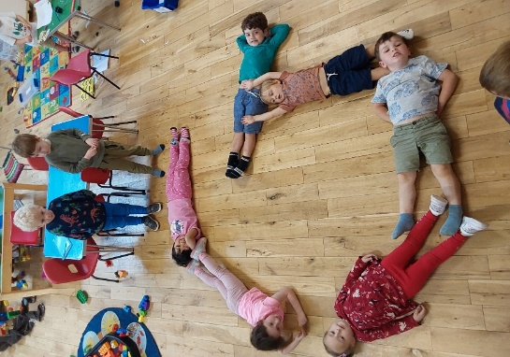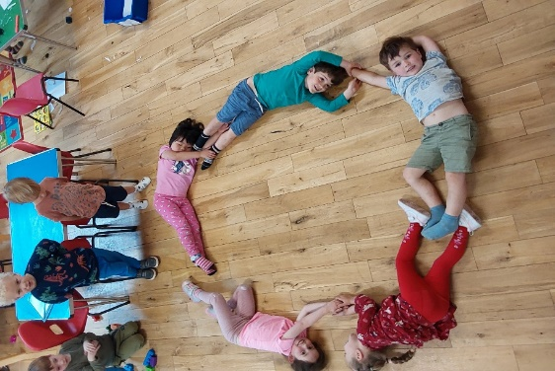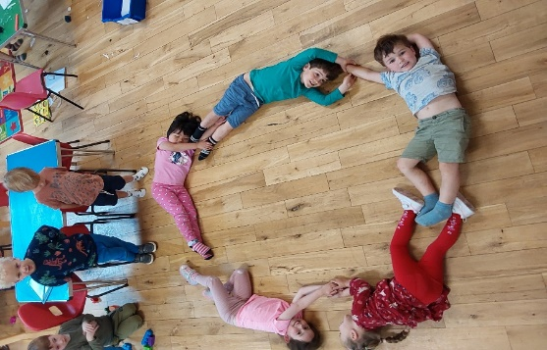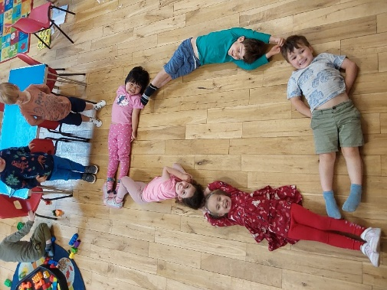

We would like Thank everyone in our local community, friends and families who continue to support Checkendon Pre-School and to wish everyone a lovely summer holidays and we look forward to new adventures in September 2024.

To find out more about Checkendon Pre-School, do visit our website [www.checkendonpreschool.co.uk](http://www.checkendonpreschool.co.uk), call us on 01491 682589, e-mail preschoolcheckendon@gmail.com or just pop in – we always look forward to welcoming you to Checkendon Pre-School.

All Enquiries please contact: [preschoolcheckendon@gmail.com](mailto:preschoolcheckendon@gmail.com), Tel: 01491 682589 [www.checkendonpreschool.co.uk](http://www.checkendonpreschool.co.uk)

**Ways you can support Checkendon Pre-School**

**Easy fundraising. Please support the Pre-School and sign up to raise funds for the Pre-School -**[**https://www.easyfundraising.org.uk/causes/checkendonpreschool/**. We will be helping to prepare them for their transition from Pre School to school, with a variety of fun activities designed to support them through their transition, preparing for their next steps](https://www.easyfundraising.org.uk/causes/checkendonpreschool/.%20We%20will%20be%20helping%20to%20prepare%20them%20for%20their%20transition%20from%20Pre%20School%20to%20school,%20with%20a%20variety%20of%20fun%20activities%20designed%20to%20support%20them%20through%20their%20transition,%20preparing%20for%20their%20next%20steps)**.**