**What’s happening at Checkendon Pre-school:**

**Look what we have been doing….**

Checkendon Pre-School have been enjoying being outside. As the season has changed to Autumn, we have been looking at the changes that this has brought to our environment. The trees are changing colour every day. The children have enjoyed learning about the different types of trees and collecting acorns, conkers and a variety of coloured leaves which have fallen from them. We continue to celebrate Harvest enjoying a variety of fruits and vegetables at snack time and talking about how they are harvested. We would like again say thank you to everyone who has brought in windfall fruit from their gardens.

Little Chefs enjoyed making their sweet treats of apple and honey cakes for Rosh Hashanah, using the apples that have been donated and honey which was kindly donated from Checkendon Court. To say thank you we walked around to Checkendon Court to deliver some homemade apple and honey cake!

The children have also been celebrating Halloween making their very own pumpkin masks and carving their very own lantern and fireworks night using the colourful leaves they have found on walks to create bonfires and splatter paint firework pictures.

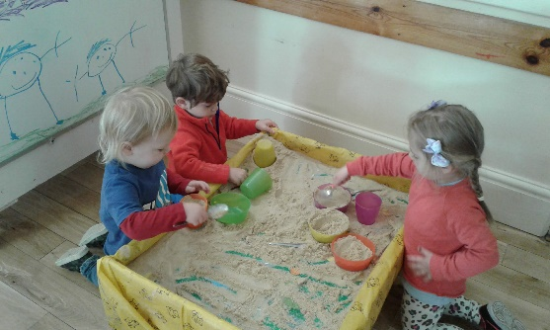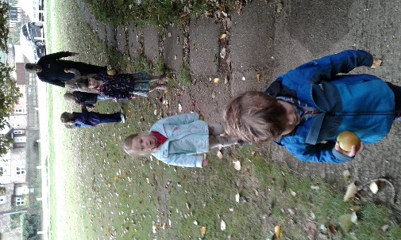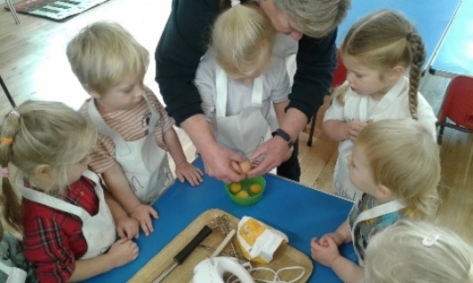

**Sand Play**

**Little Chefs**

**Autumn walks**

All Enquiries please contact: [preschoolcheckendon@gmail.com](mailto:preschoolcheckendon@gmail.com), Tel: 01491 682589 [www.checkendonpreschool.co.uk](http://www.checkendonpreschool.co.uk)

**Ways you can support Checkendon Pre-School**

**We have now signed up for Amazon smile. This means that each time you shop using amazon you can raise some funds for Checkendon Pre-school. Please follow the link** [**https://smile.amazon.co.uk/ch/1156803-0**](https://smile.amazon.co.uk/ch/1156803-0)

**Easy fundraising. Please support the Pre-School and sign up to raise funds for the Pre-School -** [**https://www.easyfundraising.org.uk/causes/checkendonpreschool/**](https://www.easyfundraising.org.uk/causes/checkendonpreschool/)