**What’s happening at Checkendon Pre-school:**

**Look what we have been doing….**

Happy New Year to you all! We wish you all a prosperous 2023. We are really pleased to be back and the children have delighted in seeing their friends and settling back into their Pre School routine again. Our theme this term is Lets investigate…. Cold. Thinking about the winter and weather such as snow and what we need to wear to keep warm. We will be focusing on one of our favourite children’s stories, The Gruffalos Child, creating a display board with all our favourite characters as well as using our delightful new story sacks to support and encourage children to enjoy some of our well loved favourites, such as The Hungry Caterpillar and Dear Zoo. This encourages the children to realise that they can, and should, imagine anything they want.

We have also been celebrating the Year of the Rabbit, for Chinese New Year; making our own Rabbit ears and learning all about these celebrations such as Chinese Dragon dancing, lucky envelopes, using chop sticks and how to say Happy New Year - Kung Hey Fat Choi and Hello - Ni Hao.

To find out more about Checkendon Pre-School, do visit our website [www.checkendonpreschool.co.uk](http://www.checkendonpreschool.co.uk), call us on 01491 682589, e-mail preschoolcheckendon@gmail.com or just pop in – we always look forward to welcoming you to Checkendon Pre-School.

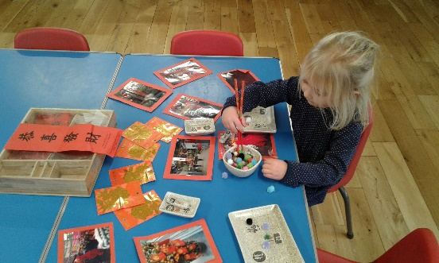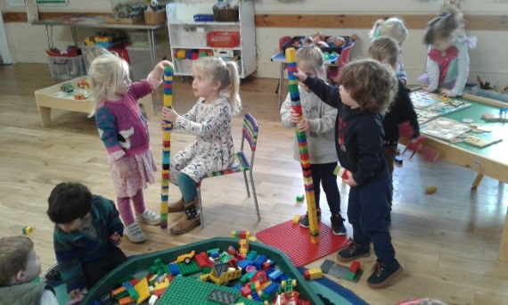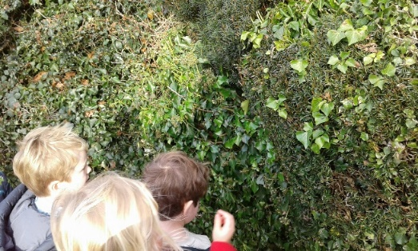

**Chines New Year**

**1**

**1**

**Building**

**Investigating**

All Enquiries please contact: [preschoolcheckendon@gmail.com](mailto:preschoolcheckendon@gmail.com), Tel: 01491 682589 [www.checkendonpreschool.co.uk](http://www.checkendonpreschool.co.uk)

**Ways you can support Checkendon Pre-School**

**We have now signed up for Amazon smile. This means that each time you shop using amazon you can raise some funds for Checkendon Pre-school. Please follow the link** [**https://smile.amazon.co.uk/ch/1156803-0**](https://smile.amazon.co.uk/ch/1156803-0)

**Easy fundraising. Please support the Pre-School and sign up to raise funds for the Pre-School -** [**https://www.easyfundraising.org.uk/causes/checkendonpreschool/**](https://www.easyfundraising.org.uk/causes/checkendonpreschool/)