**What’s happening at Checkendon Pre-school:**

**Look what we have been doing….**

We are delighted to be back at Checkendon Pre-School.

We hope that everyone has had a summer filled with excitement and adventures, enjoying the lovely sunny weather and are refreshed and ready for an exciting new term.

This term our theme will be **Let’s explore … ‘Animals’.** We will be focusing on one of our favourite books Dear Zoo. Thinking about different animals, where they come from and lots more. We have been enjoying reading the book and turning ourselves into animals to put on our Dear Zoo Display Board.

We will be exploring their interests and learning about what they enjoy doing as well as making new friends and bonding with their key person. Developing these bonds help to forms good relationships, which are crucial for development in the early years. Self-confidence means that children believe in their own abilities and capabilities. Due to this, self-confident children are more likely to challenge themselves in a learning environment. Self-confident children also trust in their ability to master their behaviour, learn new skills and tackle obstacles.

We have been celebrating Harvest, reading the story of the Little red hen, using the vegetables to do paint printing and enjoying the fruits of our labour eating the tomatoes we have grown in our gardening bed.

Pre-school have also enjoyed cooking in Little Chefs making Honey and apple cakes to celebrate the Jewish new year - Rosh Hashanah.

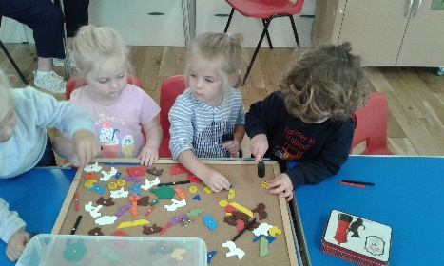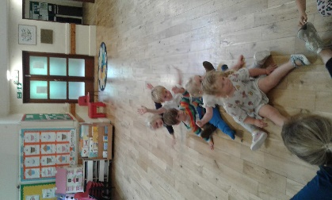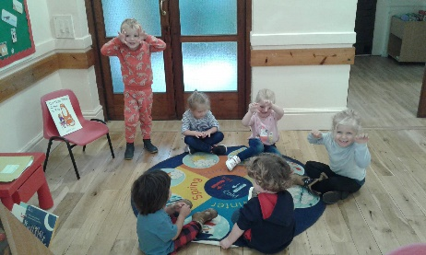

**Tiger who came to tea!**

**Diddi Dance**

**Dear Zoo**

All Enquiries please contact: [preschoolcheckendon@gmail.com](mailto:preschoolcheckendon@gmail.com), Tel: 01491 682589 [www.checkendonpreschool.co.uk](http://www.checkendonpreschool.co.uk)

**Ways you can support Checkendon Pre-School**

**We have now signed up for Amazon smile. This means that each time you shop using amazon you can raise some funds for Checkendon Pre-school. Please follow the link** [**https://smile.amazon.co.uk/ch/1156803-0**](https://smile.amazon.co.uk/ch/1156803-0)

**Easy fundraising. Please support the Pre-School and sign up to raise funds for the Pre-School -** [**https://www.easyfundraising.org.uk/causes/checkendonpreschool/**](https://www.easyfundraising.org.uk/causes/checkendonpreschool/)