**What’s happening at Checkendon Pre-school:**

**Look what we have been doing….**

The children thoroughly enjoyed their “Hey Little Bird” Puppet theatre performance for their end of term Easter treat. This was a live theatre performance which told the story of a little bird who had lost his mummy and we had to help him find her. It also had a craft workshop afterwards for the children to enjoy creating their very own little bird to take home. The children also enjoyed some brilliant Easter egg hunts in the local woodland and surrounding areas. The children were delighted when the Easter bunny paid them a visit.

We have been enjoying the outside exploring all the new things that have been appearing as we come into spring. Noticing all the details in our local community. Seeing trees start to blossom and exploring new leaves starting to bud and the flowers appearing. The children also have noticed all the flowers in our Pre-School flower bed, looking at how the flowers have been growing, talking about whether they have a fragrance, what they look like, their colours and the different parts of the flower.

We have also enjoyed a trip to the post box, posting letters in our local post box.

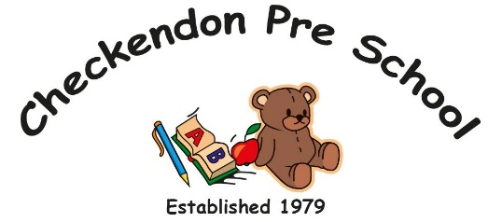

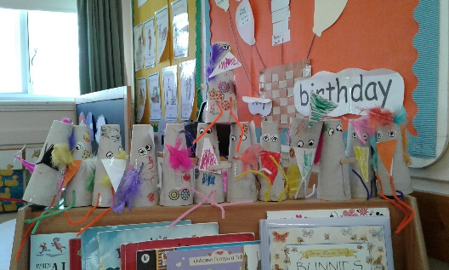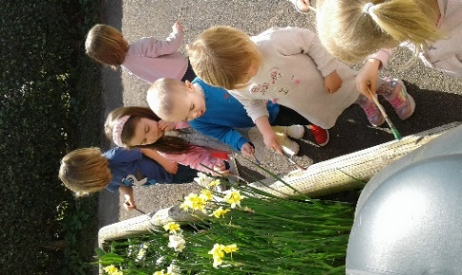 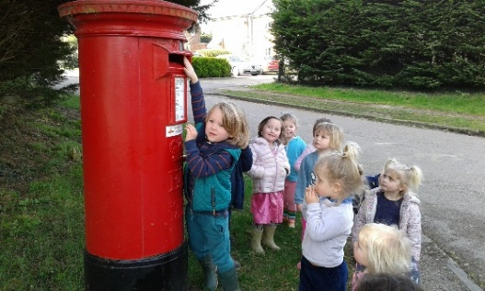

**Enjoying the flowers**

**Little Bird Craft**

**Posting letters!**

All Enquiries please contact: [preschoolcheckendon@gmail.com](mailto:preschoolcheckendon@gmail.com), Tel: 01491 682589 [www.checkendonpreschool.co.uk](http://www.checkendonpreschool.co.uk)

**Ways you can support Checkendon Pre-School**

**We have now signed up for Amazon smile. This means that each time you shop using amazon you can raise some funds for Checkendon Pre-school. Please follow the link** [**https://smile.amazon.co.uk/ch/1156803-0**](https://smile.amazon.co.uk/ch/1156803-0)

**Easy fundraising. Please support the Pre-School and sign up to raise funds for the Pre-School -** [**https://www.easyfundraising.org.uk/causes/checkendonpreschool/**](https://www.easyfundraising.org.uk/causes/checkendonpreschool/)