**What’s happening at Checkendon Pre-school:**

**Look what we have been doing….**

Welcome Back! We are delighted to be back and ready for another fun packed term.

We are delighted to have our afternoon Diddi Dance sessions back. This term the children will be learning Country and Western dancing, like a cowboy!

This term will see the start of our Transformers. Transformers is our way of supporting and preparing the children, getting them ready for their transition from Pre-School to Primary school.

We are really pleased with our new bespoke art shelves that have been built by Kelly’s partner Richard, buying materials required with the funds that we raised from our Christmas Hamper Raffle. Thank you all who brought tickets.

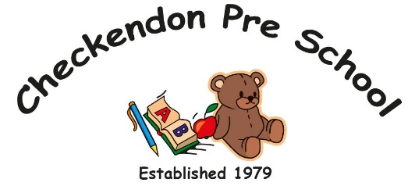We would like to say a big thankyou to Liz’s Sister Jennie, who has very kindly knitted all of these wonderful characters for our story boxes. At group time we opened our parcel to find some beautifully knitted well-loved story characters, Elmer the elephant and The Very Hungry Caterpillar including everything the caterpillar ate. Using story boxes is an excellent way to create and sustain an interest in books. Children enjoy fun and interactive activities and this is a perfect way to allow children to be more hands-on during story time, stimulating their minds and imagination by bringing stories to life. Story books are a great opportunity for children to consider the characters and locations of the story, taking the lead of a main character in a story and express themselves as the character throughout the story, helping them to develop and improve their social and communication and language skills.

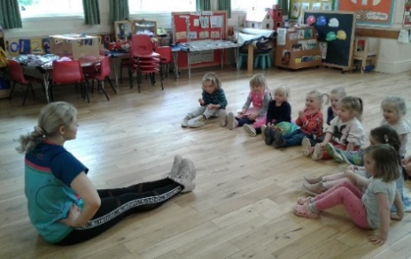 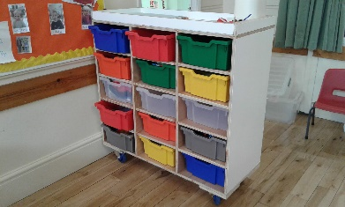 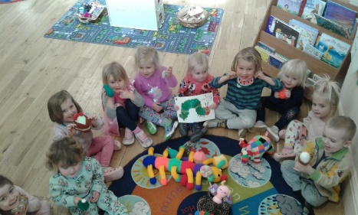

**New Art Shelves**

**Diddi Dance**

**Story surprises**

All Enquiries please contact: [preschoolcheckendon@gmail.com](mailto:preschoolcheckendon@gmail.com), Tel: 01491 682589 [www.checkendonpreschool.co.uk](http://www.checkendonpreschool.co.uk)

**Ways you can support Checkendon Pre-School**

**We have now signed up for Amazon smile. This means that each time you shop using amazon you can raise some funds for Checkendon Pre-school. Please follow the link** [**https://smile.amazon.co.uk/ch/1156803-0**](https://smile.amazon.co.uk/ch/1156803-0)

**Easy fundraising. Please support the Pre-School and sign up to raise funds for the Pre-School -** [**https://www.easyfundraising.org.uk/causes/checkendonpreschool/**](https://www.easyfundraising.org.uk/causes/checkendonpreschool/)