**What’s happening at Checkendon Pre-school:**

**Look what we have been doing….**

This term the children have been enjoying the outdoors investigating nature, looking and investigating the world around them. Nature provides countless opportunities for discovery, creativity and problem-solving. The children have been collecting lots of different items of interest that they have found during their walks in the woods and local areas and have been using these to create some beautiful ‘Outdoor Art’. Outdoor art is agreat way to engage children with the world outside and encourage them to appreciate the beauty and wonder of nature.

As we see our summer term come to a close, we look forward to leavers celebrations and end of year party celebrating with our children who will be leaving for Primary school in September and welcoming our new families, who will be joining us in September. We are very excited about our up and coming Sports Day, where the children will partake in some well-loved races, which will finish with a family picnic.

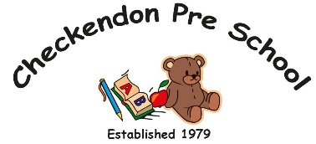We would like to thank everyone who helped, supported and particapted in Checkdnon Pre-School’s ‘Checkdendon Run’. We will let you know how much was raised and what the funds will be used for when we have a total. We hope you all have a lovely summer!

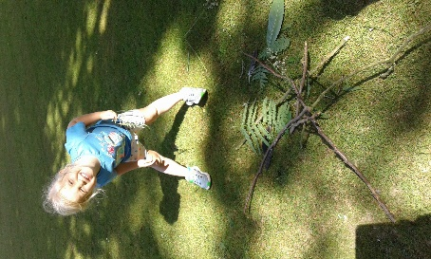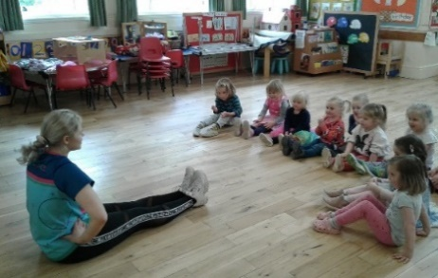 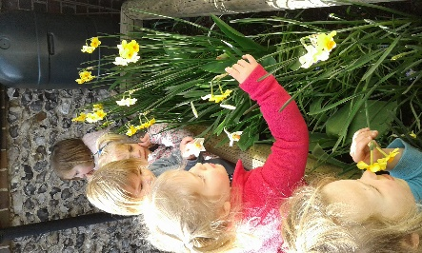

**Natural Art**

**Diddi Dance**

**Gardening**

All Enquiries please contact: [preschoolcheckendon@gmail.com](mailto:preschoolcheckendon@gmail.com), Tel: 01491 682589 [www.checkendonpreschool.co.uk](http://www.checkendonpreschool.co.uk)

**Ways you can support Checkendon Pre-School**

**We have now signed up for Amazon smile. This means that each time you shop using amazon you can raise some funds for Checkendon Pre-school. Please follow the link** [**https://smile.amazon.co.uk/ch/1156803-0**](https://smile.amazon.co.uk/ch/1156803-0)

**Easy fundraising. Please support the Pre-School and sign up to raise funds for the Pre-School -** [**https://www.easyfundraising.org.uk/causes/checkendonpreschool/**](https://www.easyfundraising.org.uk/causes/checkendonpreschool/)