**What’s happening at Checkendon Pre-school:**

**Look what we have been doing….**

For world Book day the children brought in their favourite stories and had great fun reading them to their friends. The children all dressed up as their favourite characters from well-loved stories. This is a great way to encouraging a love of books and stories from a young age helping to ignite creativity, spark curiosity and stimulate the imagination in the children.

The children celebrated Pancake Day. We talked about healthy foods and foods that are a special treat. The children made pancakes deciding what was a heathy choice and a special treat choice. This is a great way to introduce different types of food to the children that they could eat and help them begin to understand about healthy eating choices.

This term we are exploring shape. We have been encouraging the children to talk about the shapes as they play with them and modelling mathematical language. The children have also been combining shapes together to make other shapes and using language to describe these shapes. As well as spotting different shapes that we have seen within our environment.

We are also looking forward to celebrating Easter and Mothers day in the coming weeks.

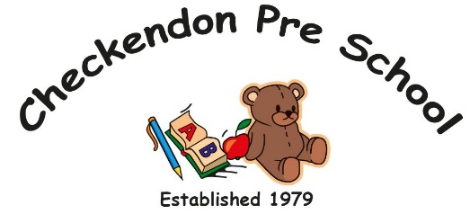

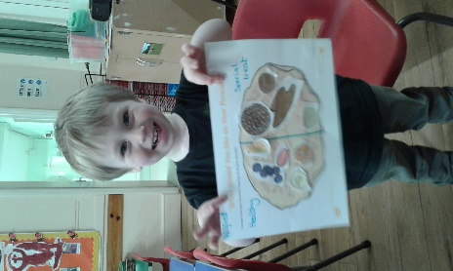 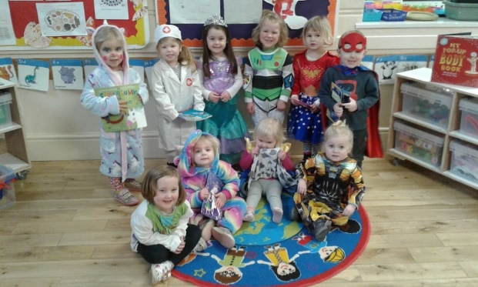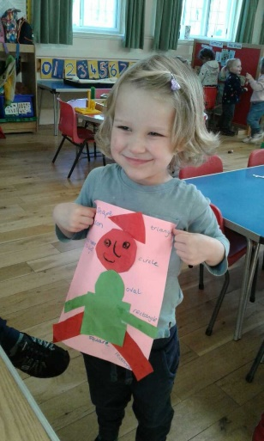

**Pancake Day**

**Exploring shapes**

**World Book Day**

All Enquiries please contact: [preschoolcheckendon@gmail.com](mailto:preschoolcheckendon@gmail.com), Tel: 01491 682589 [www.checkendonpreschool.co.uk](http://www.checkendonpreschool.co.uk)

**Ways you can support Checkendon Pre-School**

**We have now signed up for Amazon smile. This means that each time you shop using amazon you can raise some funds for Checkendon Pre-school. Please follow the link** [**https://smile.amazon.co.uk/ch/1156803-0**](https://smile.amazon.co.uk/ch/1156803-0)

**Easy fundraising. Please support the Pre-School and sign up to raise funds for the Pre-School -** [**https://www.easyfundraising.org.uk/causes/checkendonpreschool/**](https://www.easyfundraising.org.uk/causes/checkendonpreschool/)