**What’s happening Next Week: 31/01/2022**

|  |  |  |
| --- | --- | --- |
| **Day** | **What** | **Bring/Need** |
| All week | **Show and Tell** –If your child would like to show us something please can you send over a photo via Tapestry. |  |
| All week | Outdoor adventurers | Children will be making the most of our outdoor areas as much as possible, exploring the fields, woodlands and local areas. |
| All Week | Chinese New Year | We will be celebrating this festival this week. |
| Monday | Song and Rhyme time |  |
| Wednesday AM | Work out Wednesday – WOW Kids | Work out Wednesday |
| Thursday AM | Little Chefs | **TBC** |
| Friday | Special story time |  |

**Reminders to Parents**

* **Please can you make sure your child has clothing to suit the weather and warm clothing for inside due to ventilating the hall.**
* **Please can I remind you that pre-school opens at 8:30am and finishes at 3:30pm. You will be charged for early drop offs and late pickups.**
* **No one should attend the setting if they have symptoms of COVID-19 such as a new continuous cough, a high temperature (over 37.8 degrees) or a loss of taste or smell.**
* **We will continue to send you activities through Tapestry for home learning, if you are having too self- isolate.**
* **Please can you make sure if your child is not attending pre-school for any reason that you, please ring or email the preschool to let us know of their absence, thank you.**

**What happened Last Week:**

This week the children have enjoyed being outside, playing on the field and exploring the woods looking at where birds live and exploring habitats of other wildlife as well as enjoying the mud…. Squelching and jumping in muddy puddles.. we even got stuck! The extra space offered by being outdoors gives the children the sense of freedom to make discoveries by themselves. It encourages them to develop their own ideas, create games and activities to take part in with their friends. They’ll begin to understand what they can do by themselves and develop a ‘can do‘ attitude, which will act as a solid foundation for future learning. Being outdoors also provides children with more opportunities to experience risk-taking. They have the chance to take part in tasks on a much bigger scale and complete them in ways they might not when they’re indoors. They can learn to make calculated decisions such as ‘should I jump off this log?’ or ‘can I climb this tree?

We have also been making our bird feeders this week. The children used bread, bananas and bird seed mixed it all together with lard to make their own bird feeders for preschools garden and one for home. The children are very excited to put these in their gardens at home and see what birds they can spot. We would love to see photos of the bird feeders up and what birds the children have seen at home via Tapestry for the children’s Show and Tell.

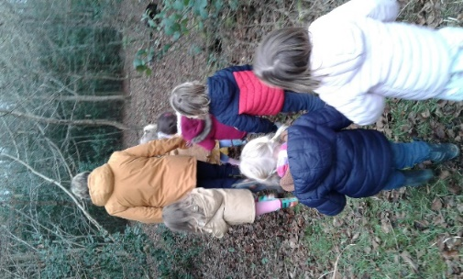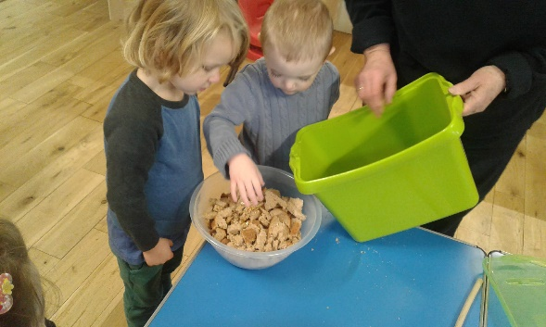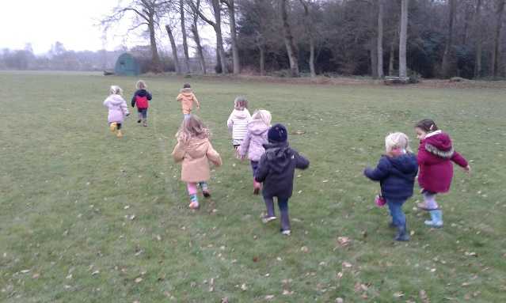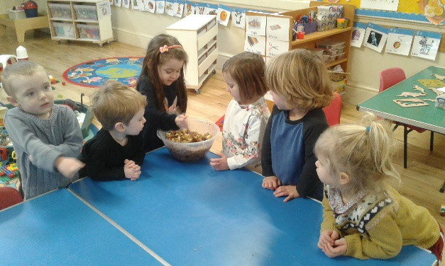

**Please can I remind you that pre-school opens at 8:30am and finishes at 3:30pm. You will be charged for early drop offs and late pickups.**

Thank you very much for your continued support. We do appreciate all of your continued support during this difficult time

**Ways you can support Checkendon Pre-School**

**We have now signed up for Amazon smile. This means that each time you shop using amazon you can raise some funds for Checkendon Pre-school. Please follow the link** [**https://smile.amazon.co.uk/ch/1156803-0**](https://smile.amazon.co.uk/ch/1156803-0)

**Easy fundraising. Please support the Pre-School and sign up to raise funds for the Pre-School -** [**https://www.easyfundraising.org.uk/causes/checkendonpreschool/**](https://www.easyfundraising.org.uk/causes/checkendonpreschool/)

**Pre-School Useful Dates:**

|  |  |  |
| --- | --- | --- |
| **Date** | **What** | **Bring/Need** |
| TBC 2022 | Checkendon Run | This is one of Pre-schools largest fundraising events. If anyone is willing to help on the day, we are looking for volunteers to marshal and run stalls for this event. If you are able to help, please let us know. If not just come along have fun and support us. Thank you |
| February 1st 2022 | Chinese New Year | Year of the Tiger. |
| Monday 14th February | Valentine’s day |  |
| Friday 18th February | Last day of term | Half term week WB 21st February 2022. |
| **Monday 6th June 2022** | **No Pre-school** | **This is the additional Queens Jubilee Inset day.** |

**Committee Information:**

Checkendon pre-school cannot run without a committee. We are always looking for new parents to join the committee. If interested in joining the committee you can email our Chairpersons – Laura and Hannah on [chairmancheckendonpreschool@gmail.com](mailto:chairmancheckendonpreschool@gmail.com).

**Online Safety Information:**

With children spending more time online at home, it is extremely important that children are made aware of online safety.   Online safety encompasses all technological devices which have access to the internet from PCs and laptops to smartphones and tablets.  Being safe online means individuals are protecting themselves and others from online harms and risks which may jeopardise their personal information, lead to unsafe communications or even effect their mental health and wellbeing.  Please refer to the Online Safety information on the Checkendon Primary School website <https://checkendon.oxon.sch.uk/permalink/4195.html> which offers many resources that will help keep your child safe online including tips, newsletters, guides and fact sheets regarding applications such as Snapchat, YouTube, TikTok and Fortnite.

**Show and Tell**

Show and tell will be done a bit differently for the time being. Please can you send a photo via tapestry or email of anything that you child would like to show us for their show and tell. All u necessary items will be sent back home. Please have a look at the parent’s board to see which day is your child’s show and tell day.

**Home learning**

Here are some links to websites providing activities you can do at home with your child to support their early learning. The government’s Hungry Little Minds campaign (<https://hungrylittleminds.campaign.gov.uk>) and the BBC’s Tiny Happy People website <https://www.bbc.co.uk/tiny-happy-people> Please take a look. The ladies are always on hand if you need any other ideas or support. Activities will continue to be put on Tapestry weekly for your child to do if you have to be in self-isolation.

**Children’s Items**

Please make sure that all child Items are named clearly. These can be dropped off at the entrance. Drink bottle needs to be brought in from home and clearly labelled with child’s name. We ask that you provide a bag with only the necessary items for your child’s daily care needs. All items should be collected at the end of each session your child attends.

**Parent’s notice board**

Parent information will be provided by email communications. And a bill board will be out the front for any important information or updates you may need. This is situated on the Left of the village hall car park entrance. Here you will find important notices and updates.

**Safeguarding**

At Checkendon Pre-School, our staff and parent committee take seriously its responsibility under Section 11 of the Children Act and duties under Working Together to Safeguard Children 2019 to safeguard and promote the welfare of children; to work together with other agencies to ensure adequate arrangements exist within our setting to identify and support those children who are suffering harm or are likely to suffer harm. We recognise that all our staff and Parent committee have a full and active part to play in protecting our children from harm, and that the child’s welfare is our paramount concern.

Our Pre-School should provide a safe, caring, positive and stimulating environment that promotes the social, physical and moral development of the individual child free from discrimination or bullying where children can learn and develop happily.

Please visit our website for more information on this: www.checkendonpreschool.co.uk