**What’s happening Next Week: Half Term**

|  |  |  |
| --- | --- | --- |
| **Day** | **What** | **Bring/Need** |
| All week | **Show and Tell** – Please do not bring in items for show and tell. If your child would like to show us something please can you send over a photo via tapestry or email thank you. |  |
| All week | Outdoor adventurers | Children will be making the most of our outdoor areas as much as possible, exploring the fields, woodlands and local areas. |
| Monday | Song and Rhyme time |  |
| Tuesday | Dough Disco |  |
| Wednesday AM | Work out Wednesday – WOW Kids | Work out Wednesday |
| Thursday AM | Little Chefs | **TBC** |
| Friday | Special story time |  |

**Reminders to Parents**

* **Checkendon Pre-School’s Annual General Meeting – 15/11/2021**
* **Please can I remind you that pre-school opens at 8:30am and finishes at 3:30pm. You will be charged for early drop offs and late pickups.**
* **No one should attend the setting if they have symptoms of COVID-19 such as a new continuous cough, a high temperature (over 37.8 degrees) or a loss of taste or smell.**
* **We will continue to send you activities through Tapestry for home learning, if you are having to self- isolate.**
* **Please can you make sure if your child is not attending pre-school for any reason that you, please ring or email the preschool to let us know of their absence, thank you.**

**What happened Last Week:**

This week we have been celebrating Diwali The estival of Light. The Festival of Light celebrates the Hindu New Year. Celebrating the victory of light over darkness and the triumph of good over evil.

Celebrating different festivals help to shape the children’s experiences and build on their knowledge of the world around them. Creating a cultural diversity environment is important in meeting the needs of all children within the setting. We have been creating Diwali hand art, drawing around our hands, using scissors to cut out our hands and then decorating them with sequins to create patterns called Mendi, also known as Henna. We also enjoyed making Diwali pops, – a special treat to enjoy. The children really enjoyed making these and have said it was Yummy!

We have also been making Rangoli patterns focusing on different sequences and repeating patterns. We have also been using shapes to create a sequence of repeating patterns. Patterns help children make predictions because they begin to understand what comes next. They also help children learn how to make logical connections and use reasoning skills.

We would like to wish you all a lovely half term and would love to see what you have been up too. You can post your lovely things you have been doing on Tapestry and your children can share these with their friends when we return on Monday 1st November.

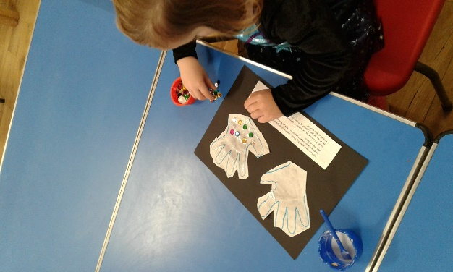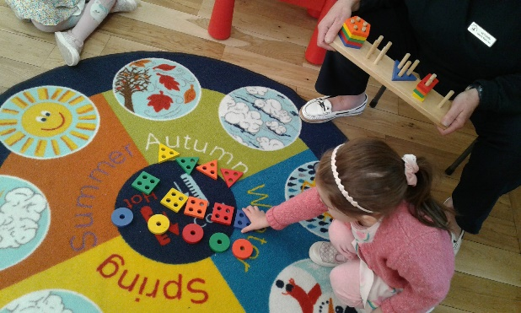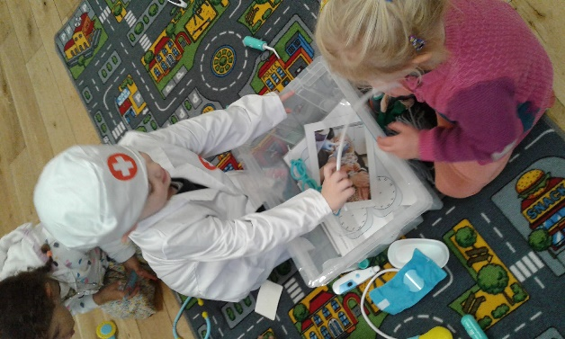

**Please can I remind you that pre-school opens at 8:30am and finishes at 3:30pm. You will be charged for early drop offs and late pickups.**

Thank you very much for your continued support. We do appreciate all of your continued support during this difficult time.

**Ways you can support Checkendon Pre-School**

**We have now signed up for Amazon smile. This means that each time you shop using amazon you can raise some funds for Checkendon Pre-school. Please follow the link** [**https://smile.amazon.co.uk/ch/1156803-0**](https://smile.amazon.co.uk/ch/1156803-0)

**Easy fundraising. Please support the Pre-School and sign up to raise funds for the Pre-School -** [**https://www.easyfundraising.org.uk/causes/checkendonpreschool/**](https://www.easyfundraising.org.uk/causes/checkendonpreschool/)

**Pre-School Useful Dates:**

|  |  |  |
| --- | --- | --- |
| **Date** | **What** | **Bring/Need** |
| TBC 2022 | Checkendon Run | This is one of Pre-schools largest fundraising events. If anyone is willing to help on the day, we are looking for volunteers to marshal and run stalls for this event. If you are able to help, please let us know. If not just come along have fun and support us. Thank you |
| 15/11/2021  8pm | Checkendon Pre-School AGM | You will be invited to join an online Microsoft teams AGM meeting. This is your opportunity to have your say and/or become more involved with the pre-school by becoming a committee member. |
| WB  18/10/21 | Diwali – Festival of light | This week we will be celebrating the Hindu festival Diwali. |
| **25th-29th October 2021** | **Half Term** | **We return on Monday 1st November 2021** |

**Committee Information:**

Checkendon pre-school cannot run without a committee. We are always looking for new parents to join the committee. If interested in joining the committee you can email our Chairpersons – Laura and Hannah on [chairmancheckendonpreschool@gmail.com](mailto:chairmancheckendonpreschool@gmail.com).

**Online Safety Information:**

With children spending more time online at home, it is extremely important that children are made aware of online safety.   Online safety encompasses all technological devices which have access to the internet from PCs and laptops to smartphones and tablets.  Being safe online means individuals are protecting themselves and others from online harms and risks which may jeopardise their personal information, lead to unsafe communications or even effect their mental health and wellbeing.  Please refer to the Online Safety information on the Checkendon Primary School website <https://checkendon.oxon.sch.uk/permalink/4195.html> which offers many resources that will help keep your child safe online including tips, newsletters, guides and fact sheets regarding applications such as Snapchat, YouTube, TikTok and Fortnite.

**Show and Tell**

Show and Tell will be done a bit differently for the time being. Please can you send a photo via tapestry or email of anything that you child would like to show us for their show and tell. All u necessary items will be sent back home. Please have a look at the parent’s board to see which day is your child’s show and tell day.

**Home learning**

Here are some links to websites providing activities you can do at home with your child to support their early learning. The government’s Hungry Little Minds campaign (<https://hungrylittleminds.campaign.gov.uk>) and the BBC’s Tiny Happy People website <https://www.bbc.co.uk/tiny-happy-people> Please take a look. The ladies are always on hand if you need any other ideas or support. Activities will continue to be put on Tapestry weekly for your child to do if you have to be in self-isolation.

**Children’s Items**

Please make sure that all child Items can be dropped off in the box provided at the entrance. Packed lunches to be able to be eaten from their lunch box, as no food will be able to be heated to minimise contact. Drink bottle needs to be brought in from home and clearly labelled with child’s name and put in the box at the drop off point. We ask that you provide a bag with only the necessary items for your child’s daily care needs and place it in the box provided. All items should be collected from the box at the end of each session your child attends.

**Parent’s notice board**

Parent information will be provided by email communications. And a bill board will be out the front for any important information or updates you may need. This is situated on the Left of the village hall car park entrance. Here you will find important notices and updates.

**Safeguarding**

At Checkendon Pre-School, our staff and parent committee take seriously its responsibility under Section 11 of the Children Act and duties under Working Together to Safeguard Children 2019 to safeguard and promote the welfare of children; to work together with other agencies to ensure adequate arrangements exist within our setting to identify and support those children who are suffering harm or are likely to suffer harm. We recognise that all our staff and Parent committee have a full and active part to play in protecting our children from harm, and that the child’s welfare is our paramount concern.

Our Pre-School should provide a safe, caring, positive and stimulating environment that promotes the social, physical and moral development of the individual child free from discrimination or bullying where children can learn and develop happily.

Please visit our website for more information on this: www.checkendonpreschool.co.uk